MANAGING MENTAL AND EMOTIONAL WELLNESS DURING COVID-19  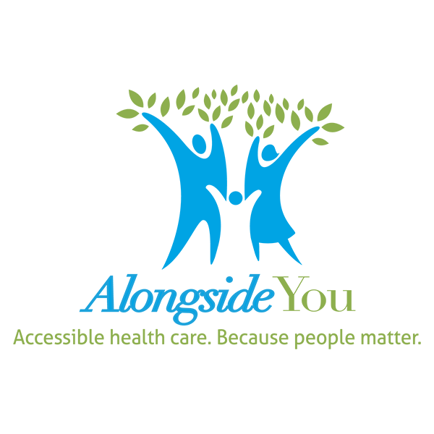  COVID-19 has changed the landscape of our work, and our home life. The struggle to maintain the mythical work/life balance has always been tough, and now we're getting a crash course in resilience.  In this webinar, we'll present information anxiety, stress, and burnout related to COVID-19, and give tips on how to manage our mental and emotional wellbeing through the pandemic while supporting our kids.  It's time we take care of ourselves - body, mind and spirit. If we pay attention to our needs, take care of ourselves, and connect with each other, we can thrive through this pandemic together and maintain our resilience!  Facilitator:  Andrew Neufeld is the Co-Founder and the Executive Director of Alongside You, Principal at Immerse Consulting, and Clinical Faculty at the University of British Columbia. He is a Registered Clinical Counsellor, Certified Birkman© Consultant and Leadership Consultant, with over a decade of experience working with individuals, couples, families, and professionals. His passion is in helping organizations clarify their goals and passions and design plans on how to get to where they want to be and thrive along the way.  THURSDAY, OCTOBER 29th AT 7:00 PM VIA ZOOM  REGISTRATION LINK BELOW:  https://alongsideyou.zoom.us/webinar/register/WN_rnSxaxPpQlWOMTBU7eS4Ig |  | PRESENTED BY:  a free  education series for parents and cargivers  Session 2  An alongside you event  space is limited  Email questions for Andrew Neufeld ahead of time to:  Kirsten Hermanson, Manager – Prevention and School Wellness  khermanson@deltasd.bc.ca

