It’s Grade 7 Hoodie Time!

September 30th, 2020

Dear Parents/Guardians of Grade 7 Students:

Once again, Grade 7 Students have the opportunity to order a Grade 7 hoodie. Hoodies are black, with 2021, in green and white screen, printed on the back. There are two styles available - pullover or zip style. Students also have the option of having their name printed on the back. If selecting this option, be sure to check off the box below and print name clearly (as you would like it to appear).

We want every grade 7 student who would like a hoodie to have one. If there are any concerns about financial hardship, please let your child’s teacher, or Mme Greenhalgh, know. We can assist with this.

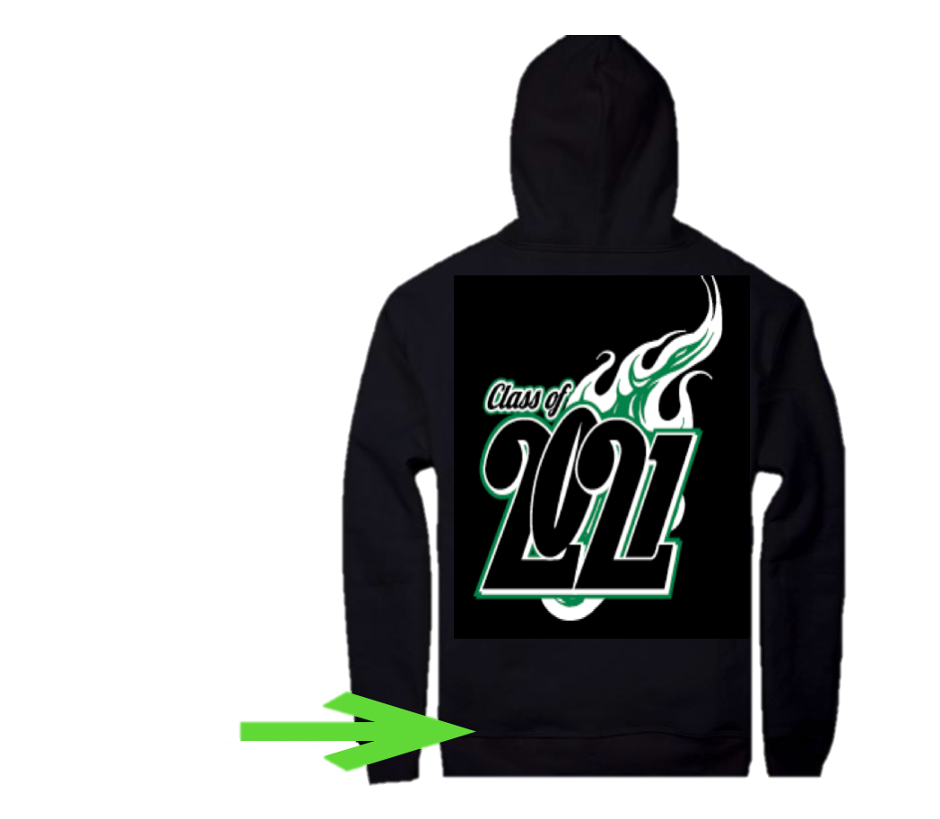
ORDERS ARE DUE OCTOBER 14TH, 2020

Due to COVID restrictions, we are unable to provide sizing samples for students to try on.

Please refer to the sizing chart:

Add name here (optional)

Beyond Mars (clothing supplier) reserves the right to substitute a product of like or better quality in order to complete the production of this order for your school. We will not be responsible for incorrectly sized orders.

Student’s Name:________________________________________________

Div:________ Phone: _____________________________

[ ] Optional - Name on back
Print name

clearly

ORDERS ARE DUE OCTOBER 14TH, 2020

